Chapter-1

INTRODUCTION

This chapter begins with the concepts of Student learning and career guidance recommendation system and its implementation in solving the current real time issues as finding best learning and career opportunities. Then the focus is on the idea behind the development of a model for student learning and career Prediction.

  - Introduction:

1.2 Motivation:

Summary:

1.3 Report Organization:
Chapter 1: Introduction
This chapter gives us an outlook on different concepts like give prediction to students based on their unique qualities, weaknesses and strength, predict possible learning and career guidance. It also gives us information of how this technique is used in student learning and career guidance.

Chapter 2: Problem Statement
Develop an intelligent and user-friendly Student Learning and Career Guidance Recommendation System that leverages advanced data analysis, artificial intelligence, and machine learning techniques to provide personalized recommendations to students.

Chapter 3: Design Details
This chapter focuses on system architecture & modules with diagrams.

Chapter 4: Implementation Details
This chapter reveals implementation details of all the modules defined in the dissertation work and the tools used for development.

Chapter 5: Experimental Results
This chapter gives information on the experimental results obtained and the interpretation of results.

Chapter 6: Evaluation of Results
This chapter focuses on quantifying effectiveness of the work using different analysis parameters.

Chapter 7: Conclusion
This chapter consist of concluding remark of the dissertation work. It explains the test results and productivity of the developed system.

Chapter-2

PROBLEM STATEMENT

This chapter focuses on the literature review of different systems for learning and career guidance recommendation. It includes summary of different techniques related to recommendation, Curriculum Learning, career recommendation.

2.1 Literature Survey:

Table 1. Shows a short represent review table for _________________
Sr.no | Reference | Objective | Limitation
1
2
3
With the extensive literature review following research gap we identify
RG1:
RG2:
RG3:
To overcome these research gap, our proposed model we decide some objectives of system.
Following are the objective of proposed system:
Obj1:
Obj2:
Obj3:
Obj4:
2.2 Need of Work:

2.3 Problem Statement
To develop a model that will predict Student learning and career guidance recommendation system.
2.4 Objectives:

Summary: Literature survey is designed in such a way that an effective

Chapter-3

DESIGN DETAILS

In the modern educational landscape,

3.1 System Architecture:

Fig. 3.1 System Architecture for Proposed System
accuracy and effectiveness in recommending suitable learning paths and future careers can be assessed and improved. This process ensures that the recommendation system provides valuable and precise guidance to students based on data-driven insights.

3.2 System design Model:
The methodology comprises four main phases that are continually repeated:
The Planning Phase:
It would define the project objectives, requirements, and constraints related to student career prediction, anxiety detection. This would include determining the minimum level of accuracy and speed required for the career prediction, anxiety detection system and identifying the types of faces to be detected and the data to be used for training the system.
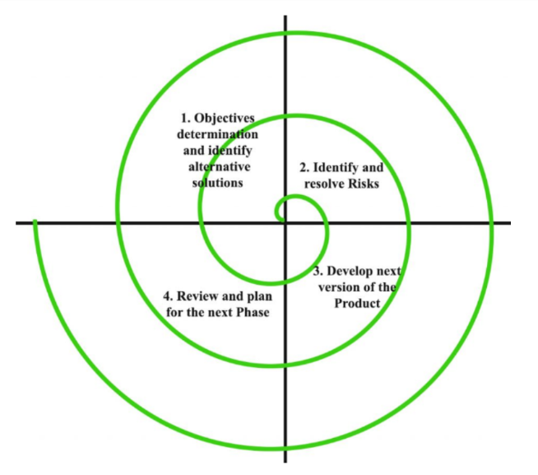
The Risk Analysis Phase:
It would analyze potential risks associated with career prediction, anxiety detection such as algorithmic accuracy or constraints related to input data. Strategies would then be developed to mitigate or avoid these risks.
The Development Phase:
It would create a prototype or a partial solution for anxiety detection, which could involve training a machine-learning prototype on a small set of datasets to evaluate accuracy and prediction. The evaluation of system would be evaluated, and areas for improvement are identified.
The Evaluation Phase:
In this, the prototype would be tested & evaluated, and feedback would be collected from users. Based on the results, the requirements and objectives for the next iteration would be refined, and any new risks or alternatives will be identified.
3.3 System Design Diagrams

Write down Theory about system design diagram.

3.3.1 Data Flow Diagram

3.3.2 Activity Diagram:

3.3.3 Sequence Diagram:

3.3.4 Use Case Diagram:

3.4 Dataset Design:
3.4.1 Sample Dataset:

Summary:

In this chapter the design of system architecture is explained in detail. The spiral system design model has been explained with different phases. The data flow diagram, state transition diagram, sequence diagram and use case diagram for system is are drawn to understand the flow of system.

Chapter – 4

Implementation Details

- Development Tools:
In this section, we outline the essential hardware and software requirements as well as the key libraries necessary for the successful development and implementation of the student learning and career guidance recommendation system.
4.1.1 Hardware Requirements: To facilitate the optimal performance and seamless execution of the learning and career guidance recommendation system, the following hardware specifications are recommended:
Processor (Intel i5 or greater): A capable processor such as Intel Core i5 or higher is recommended to ensure efficient processing of image and video data during the drone detection process.
16 GB RAM or More: with a minimum of 16 GB RAM or more, is essential for handling the computational demands of machine learning algorithms and real-time video processing. Minimum 128 GB SSD: A Solid State Drive (SSD) with a minimum capacity of 128 GB is advised to provide swift data access and reduce load times, contributing to the overall responsiveness of the system.
Minimum 1T HDD or above: A Hard Disk Drive (HDD) with a minimum capacity of 1TB or above is advised to stored data when turned off.
4.1.2 Software Requirements: The software requirement for the learning and career guidance recommendation system should meet the following prerequisites:
Windows 10 OS or Above: The system should run on Windows 10 operating system or a more recent version to ensure compatibility with modern software tools and libraries.
Python 3.10: Python serves as the programming language of choice for its versatility and extensive ecosystem. Version 3.9 or higher is recommended to leverage the latest features and enhancements.
VS Code (Visual Studio Code): Visual Studio Code is a powerful and user-friendly integrated development environment (IDE) that aids in coding, debugging, and managing project files. 4.1.3 Libraries: The following libraries are crucial for implementing various functionalities within the learning and career guidance recommendation system:
OpenCV: OpenCV (Open Source Computer Vision Library) is a versatile and widely-used library that provides tools for image and video analysis, manipulation, and computer vision tasks.
TensorFlow: TensorFlow, a deep learning framework developed by Google, enables the construction and training of complex neural networks, including object detection models. Numpy: Numpy is a fundamental library for numerical computations in Python, essential for handling arrays and matrices efficiently.
By adhering to these hardware and software requirements, as well as incorporating the specified libraries, developers can establish a robust and efficient foundation for designing, training, and deploying the learning and career guidance recommendation system, thus ensuring its accuracy, performance, and effectiveness in real-world applications.
- Details of Development:
4.2.1)

- Experimentation:
4.3.1 Experiment Setup:

4.3.2 Dataset view:

4.3.3 Database View:

Summary:

Chapter – 5

RESULTS AND DISCUSSION

The proposed model for ___________________________follows implementation on above algorithms. The observations and results are as follows:
5.1 Analysis

5.2 Observation

Summary:

The "Experimental Results" section provides a comprehensive overview of the real-world performance and effectiveness of

Chapter – 6

CONCLUSION

6.1 Conclusion:
The proposed model _________________________________________________________
_________________________________________________________________________________________________________________________________________________

6.2 Future Scope

Chapter – 7

PAPERS PUBLISHED

7.1 Papers Published:
1.
2.
Paper Title: Published on:

Chapter- 8

REFERENCES

References:

